W3 Assignment

1. Find the slope-intercept form of the equation of the line that passes through the given point and has the indicated slope m. Sketch the line.
(0,0), m = 3

2. Find the slope-intercept form of the equation of the line that passes through the given point and has the indicated slope m. Sketch the line.
(4, 10/3), m = 0

3. Determine whether the lines are parallel, perpendicular, or neither.
L1: y = 7/8 x – 7

L2: y = -8/7 x – 8

4. Find the slope-intercept form of the equation of the line passing through the points. Sketch the line.
(4,-3), (-4,4)

5. Which of the following equations does not represents y as a function of x?

6. Evaluate the function g(y) = 10 – 4y at g(s + 11).

7. Evaluate the function at f(-2).
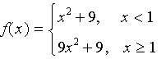
8. Does the table describe a function?
Input value | 1 | 3 | 4 | 3 | 1
Output value | –12 | –7 | 0 | 7 | 12

9. Does the table describe a function?
Input value | 10 | 30 | 10 | 20 | 40
Output value | 2001 | 2002 | 2003 | 2004 | 2005

10. Evaluate the function q(x) = 1 / (x² – 5) at q(3).

11. Find the difference quotient and simplify your answer.
,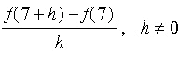

12. Find the real values of x such that f(x) = 0.
f(x) = x² – 8x + 65

13. Find the real values of x such that f(x) = 0.
f(x) = 81x² – 49

14. Find the domain of the function.
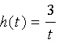
15. Find the real values of x such that f(x) = 0.
f(x) = x³ – x² – 9x + 9

16. Find the average rate of change of the function from x₁ = 1 to x₂ = 5.
f(x) = x² – 8x + 8

17. Find the zeros of the function algebraically.

18. Find the zeros of the function algebraically.
19. Find (f + g)(x).
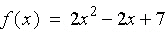
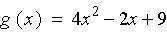

20. Find (f – g)(x).

21. Evaluate the indicated function for 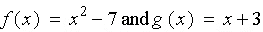
(f – g)(t + 2)

22. Find (f/g)(x). What is the domain of f/g?
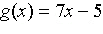

23. Find (f – g)(x).
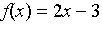
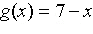

24. Find g ◦ f
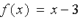
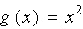

25. Find g ◦ f
